Lab 9 CCS3101
20 June 2025
- Solve the following questions and demonstrate your solutions to me in this lab or in the next lab. For record-keeping, submit also your solutions and screenshots of their output to PutraBlast.
- Evaluation will be done according to the lab rubric on PutraBlast. I will ask questions accordingly.
*******************************

Questions:

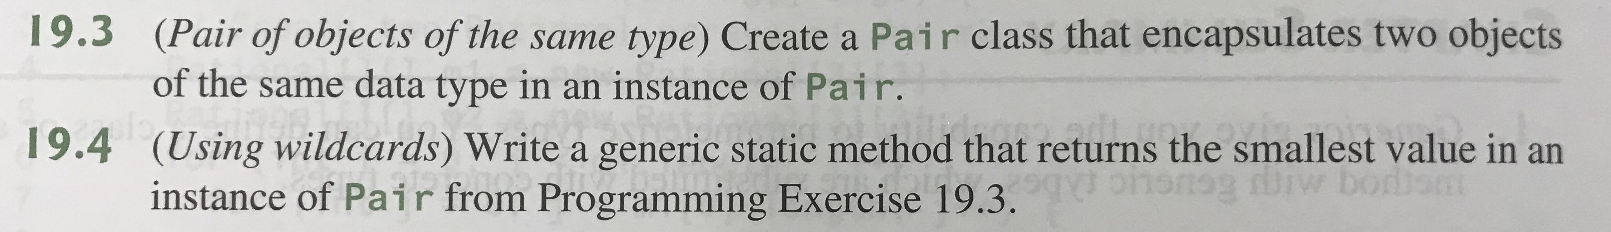

Also for 19.4, do test code that obtains the smallest value from an int Pair and from a double Pair.

(The questions are from the 11th edition of the Liang textbook. The questions do not appear in the 10th edition.)

